SAFAPLACE
A CHARITY INCORPORATED ORGANISATION (CIO)
FINANCIAL STATEMENTS
FOR THE YEAR ENDED 31 JULY 2020

CHARITY REGISTERED NUMBER 1179202

LONDON ACCOUNTANCY PRACTICE
SOJOURNER TRUTH CENTRE
161 SUMNER ROAD
LONDON
SE 15 6JL

SAFAPLACE
FINANCIAL STATEMENTS
FOR THE YEAR ENDED 31 JULY 2020

CONTENTS Page

Contents 2

Administrative Information 3

Report of the Trustees 4-8

Independent Examiner’s Report 9

Statement of Financial Activities 10

Balance Sheet 11

Notes to the Accounts 12

Detailed Income & Expenditure 13

SAFAPLACE
ADMINISTRATIVE INFORMATION
AS AT 31 JULY 2020

Executive Committee Members
Michael Collins Chairperson
Jane Acton. Secretary
Rose White Treasurer

FORMAL ADDRESS 82 Hawksley Road
Stoke Newington
London N16 0TJ

BANKERS Co Operative Bank Plc
1 Islington High Street
The Angel
London N1 9TR

INDEPENDENT EXAMINER London Accountancy Practice
Sojourner Truth Centre
161 Sumner Road
London SE15 6JL

SAFAPLACE
Report of The Trustees
For The Year Ended 31st July 2020

Structure, Governance and Management
SAFAPLACE is a charitable incorporated organisation (CIO) registered on 11th February 2015 and governed by its constitution. The CIO was established under a constitution which defines the objects and power of the charitable organisation and is governed by such.
As of July 2020, the Trustees are:
Jane Acton (Secretary), Salma Asokomhe, Michael Collins (Chair) Annie Gammon, Sarah Finke and Rose White (Treasurer).

Charitable Aims and Objectives
Its aims are:

a. To make Stoke Newington a neighbourhood where young people can find help and support for all aspects of mental health

b. To make Stoke Newington School a centre for positive mental health awareness and to share and learn with other schools and the wider community.

Safaplace became officially established as a registered charity no 1179202 in July 2018.

Safaplace

Safaplace is a charity that aims to provide an environment where all of the community can feel safe – mentally, emotionally and physically. The charity continues to fundraise, campaign on mental health issues and promote a programme of activities aimed at advancing positive mental health and wellbeing.
It was established to commemorate the lives of Rachel Finke and Harry Lisle.

SAFAPLACE became officially established as a registered charity no 1179202 in July 2018.

As of July 2020, the Trustees are:
Jane Acton (Secretary), Salma Asokomhe, Michael Collins (Chair) Annie Gammon, Sarah Finke and Rose White (Treasurer).

The Trustees have benefitted from the support of a number of Associates who have worked tirelessly to promote the charity and its aims. We are very grateful to: Richard Allen, Antonia Canning, Skye Fitzgerald McShane, Kathy Manners, Spike Richards, Tom Moore and Andrea Watts- we could not do this without you.

We would also like to thank our supporters who have funded and supported our many initiatives this year including our conference, our reflective garden and the City Haven project. They are: Pageant Media, Linda Wilson, Antonia De Benito, Sophie and Tony Cunningham at Twenty Twenty-One in Islington, Jenniffer Cullen, Tony Hassan, Megan Shacklock, Phil Watson, The Hackney Tree Nursery, Michele Whitehead, Fran Paffard, Amber and Lee Brockway and Beaucatcher Salon.

Applications for funding: Application proformas have been made available on our website (Safaplace.org) and this information has been made, available via the Hackney Education Office, to all Hackney schools. We’re looking forward to supporting more projects next year.

Report on Activities 2019

The Trustee’s 2018-2019 report was made available at its 2019 Conference and can be found on the Safaplace website.

Safaplace hosted its very successful second annual conference: ‘Getting the Right Help’. It took place on Saturday 11th May 2019 on the premises of Stoke Newington School. The keynote speech was delivered by Emily Harrison, a poet, author and English teacher from Stoke Newington School. Workshops were on a variety of issues delivered by a range of experts including ‘A’ space, Meg Zeenay Wamithi, Dr Adenike Ajigini, Ingrid Cleaver, and Dr Raj Sekaran from the Royal College of Psychiatrists.

Report on Activities 2020
This document constitutes the Trustees’ 2019-2020 annual report, including the financial review below.

In addition to our conferences, we have supported Stoke Newington School with a number of wellbeing and mental health initiatives including Educational Support charity to support teaching staff’s wellbeing, gardening club, which ran before the pandemic. We are delighted to announce that Stoke Newington School has been accredited the Wellbeing Award for Schools, a nationally-recognised award, administered by Award Place and The National Children’s Bureau. This award demonstrates Stoke Newington School’s ongoing commitment to pupil and staff wellbeing, as well as that of the wider community.
Activities ongoing in school
The outbreak of COVID19 and the extraordinary situation we have found ourselves in has been immensely challenging for everyone. One of the most significant public health measures implemented during the COVID-19 pandemic has been extended periods of ‘lockdown’, and associated school closures. The evidence on the direct impact of lockdown on mental health and wellbeing of children and young people has shown there to be increased levels of distress, worry and anxiety. Some likely reasons include increased feelings of loneliness and worries about school and the future. Now, more than ever, we need to find ways to support our young people in order to help them build hope and resilience for the future.

In order to do this during lockdown, Safaplace worked with other charities whose aims align with our own. We have made contact with and supported the Trussell Trust and North London Family Action.

Future plans and projects
We are hoping to work with Hackney Mosaics on a project that will link the Stoke Newington School students and the Safaplace reflective garden sometime in the summer and hope to have more information on this very soon.

SAFAPLACE
REPORT OF THE TRUSTEES
FOR THE YEAR ENDED 31 JULY 2020
FINANCIAL REVIEW
The results of the year’s operation are set out in the attached financial statements. The net movement in funds for the year amounted to (£9,740) Compared with a surplus of £46,951 in 2019 and the retained reserves as at 31st July 2020 is £37211 compared with £46951 last year.
RESERVE POLICY
The Charity Commission requires charities to determine and explain their policy for free reserves. The trustees have reviewed the organisation’s free reserves policy and have turned its entire unrestricted fund into an emergency reserve to enable SAFAPLACE to meet its obligations in the event of a shortfall in income or sudden upturn in expenditure.
RISK MANAGEMENT
The trustees have examined the major risks which SAFAPLACE faces and believe that maintaining their free reserves at a reasonable level, combined with their annual review of the controls over key financial systems will provide sufficient resources in the event of adverse conditions. The trustees have also examined other operational and business risks which they face and confirm that they have established systems to mitigate the significant risks.
TANGIBLE FIXED ASSETS
The organisation has no fixed assets
FUNDS AVAILABLE
The present level of funding is adequate to support the continuation of the charity operations for the medium term, and the trustees consider the financial position of the charity to be satisfactory.
VOLUNTEERS
SAFAPLACE recognises the significant contributions made by the volunteers.

SAFAPLACE
STATEMENT OF THE TRUSTEES’ RESPONSIBILITIES
FOR THE YEAR ENDED 31 JULY 2020
The Management Committee are required to prepare financial statements which give a true and fair view of the state of affairs of the project and of the income and expenditure of the project for that period. In preparing these financial statements, the management committee are required to:
- select suitable accounting policies and apply them consistently;
- make judgements and estimates that are reasonable and prudent;
- prepare the financial statements on the going concern basis unless it is

inappropriate to presume that the project will continue in operation.

The Management Committee are responsible for keeping proper records which disclose at any time the financial position of the project. They are also responsible for safeguarding the assets of the organisation and hence for taking reasonable steps for the prevention and detection of fraud and other irregularities.
INDEPENDENT EXAMINER’S REPORT

TO THE TRUSTEES OF SAFAPLACE
ON THE ACCOUNTS FOR THE YEAR ENDED 31 JULY 2020 WHICH ARE SET OUT ON PAGES 10-11.
Respective responsibilities of trustees and examiner
The charity's trustees are responsible for the preparation of the accounts. The charity's trustees consider that an audit is not required for this year under section 144(2) of the Charities Act 2011 (the 2011 Act) and that an independent examination is needed.
It is my responsibility to:
- examine the accounts under section 145 of the 2011 Act;
- to follow the procedures laid down in the general Directions given by the Charity Commission under section 145(5)(b) of the 2011 Act; and
- to state whether particular matters have come to my attention.

Basis of independent examiner's report

My examination was carried out in accordance with the general Directions given by the Charity Commission. An examination includes a review of the accounting records kept by the charity and a comparison of the accounts presented with those records. It also includes consideration of any unusual items or disclosures in the accounts, and seeking explanations from you as trustees concerning any such matters. The procedures undertaken do not provide all the evidence that would be required in an audit and consequently no opinion is given as to whether the accounts present a 'true and fair view' and the report is limited to those matters set out in the statement below.

Independent examiner’s report
In connection with my examination, no matter has come to my attention: which gives me reasonable cause to believe that in any material respect:
- The accounting records were not kept in accordance with the section 130 of the Charities Act; or
- The accounts did not accord with the accounting records; or
- The accounts did not comply with the applicable requirements concerning the form and content of the accounts set out in the Charities (Accounts and Reports) Regulations 2008 other than any requirement that the account give a ‘true and fair’ which is not a matter a matter considered as part of the independent examination.
I have no concerns and have come across no other matter in connection with the examination to which attention should be drawn in this report in order to enable a proper understanding of this account to be reached.

Signed………………………………………………..Date:………………………

A Adebambo, MBA, CGMA, ACG

London Accountancy Practice

Sojourner Truth Centre

161 Sumner Road

London SE15 6JL

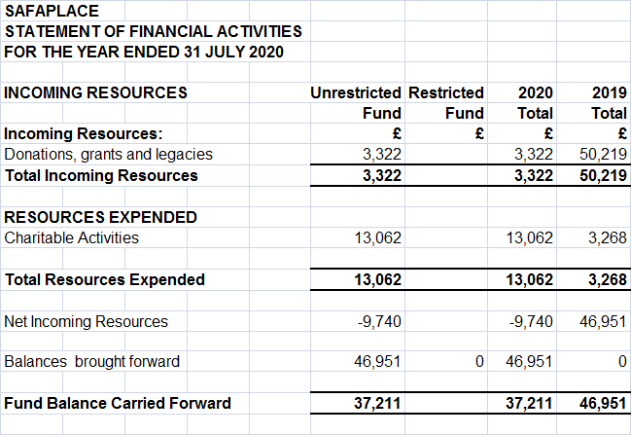

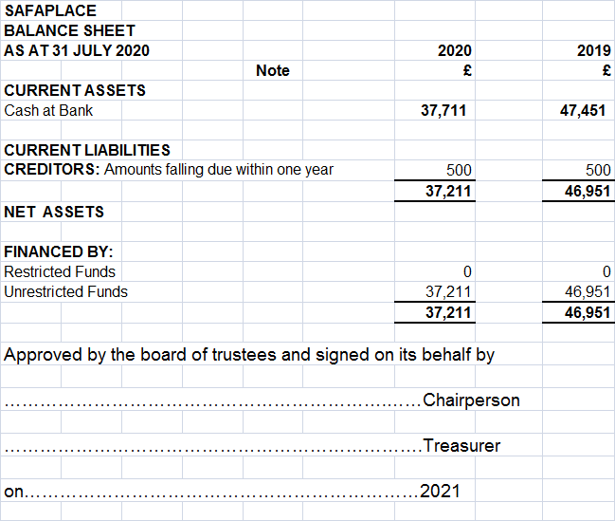SAFAPLACE
NOTES TO THE ACCOUNTS

1. ACCOUNTING POLICIES
1.1 Basis of Preparation of Financial Statements

The financial statements are prepared under the historic cost convention and

included the results of the charity’s operations which are described in the

Management Committee’s Report and all of which are continuing.

The accounts have been prepared in accordance with the Statements of

Recommended Practice for charity accounts.

The charity has taken advantage of the exemption of Financial Reporting

Standard No 1 from the requirements to produce a cash flow statement on the basis that it qualifies as a small charity.

1.2 Incoming Resources
1.2.1 Revenue grants are credited to the Statement of Financial Activities on the earlier date of when they are received or when they are receivable, unless they relate to a specific future period, in which case they are included on the Balance Sheet as deferred income to be recognised in the future accounting period.
1.2.2 Grants received for specific purposes are accounted for as restricted funds in the Statement of Financial Activities.
1.3 Restricted Funds
Restricted funds are to be used for specific purposes as laid down by the donor. Expenditure which meets these criteria is identified to the fund, together with a fair allocation of management and support costs.
1.4 Unrestricted Funds
Unrestricted funds are donations and other incomes received or generated for the objects of the organisation without further specified purpose and are available for general funds.
1.5 Designated Funds
Designated funds are unrestricted funds earmarked by the Management Committee for particular purposes.
1.6 Tangible Fixed Assets
All expenditure that related to equipment has been charged to the Statement of Financial Activities in the year of acquisition. A register of assets is maintained.
2. CREDITORS AND ACCRUALS 2020 2019

£ £

Accountancy fees 500 500

